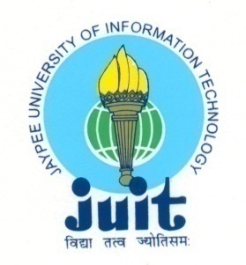 | JAYPEEUNIVERSITY OF INFORMATION TECHNOLOGY  (Established by H.P.State Legislative vide Act No. 14 of 2002)  Waknaghat, P.O. Dumehar Bani, Kandaghat, Distt. Solan – 173234 (H.P.) INDIA  Website :www.juit.ac.in  Phone No. (91) 01792-257999 (30 Lines)  Fax : (91) 01792 245362
NAAC Criteria Supporting Document
Criteria 4

4.2.3 Books/e-Books

Criteria | Criterion IV – Infrastructure and Learning Resources
Key Indicator | 4.2 Library as a Learning Resources
Metric | 4.2.3: Average annual expenditure for purchase of books/ e-books and subscription to journals/e-journals during the last five years (INR in Lakhs)

Additional Information
Sr. No. | Document Title | View Document
1 | Books
1 | Books 2017-18 | View
1 | Books 2018-19 | View
1 | Books 2019-20 | View
1 | Books 2020-21 | COVID AFFECTED
1 | Books 2021-22 | View
2 | eBooks under perpetual access from 2017-22 | View

